 | This fact sheet is about: Student Finance
 | If you live mostly in Wales and you study in the UK you may get money to pay for your education and living costs.
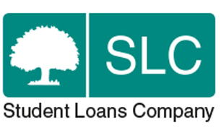 | The Student Loans Company decides  if students can get help.
 | They also sort out paying the money.
 | The Student Loans Company has a complaints policy. If you disagree with their decision you can appeal.
 | What do you do before you contact the Ombudsman?
 | Complain to the Student Loans Company.
What can the Ombudsman do?
We may be able to help if your
complaint is about:
 | - bad communication.
 | - bad assessment and bad handling of requests for student money.
 | - bad handling of money.
What can’t the Ombudsman do?
We cannot:
 | - look at complaints about things Welsh Government does not deal with.
- look at decisions that were made
in the right way.
 | Things to think about
 | If your complaint is about something before April 2015 you may need to speak to the Council first.
 | You do not need a solicitor or advocate to complain to the Ombudsman.
The Ombudsman can tell the Student Loans Company what we think it should do if we think it has done
something wrong.
 | More information
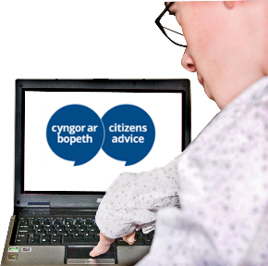 | The Citizens Advice Bureau gives help and advice. They may help you complain: www.citizensadvice.org.uk/
 | There is more on complaints about student finance at:
 | Student Finance Wales: www.studentfinancewales.co.uk
 | and The Student Loans Company: www.slc.co.uk/
If you are still not sure if the
Ombudsman can help, contact us.
 | How to contact the Ombudsman
 | 0300 790 0203
ask@ombudsman.wales
www.ombudsman.wales
 | @OmbudsmanWales
The Public Services Ombudsman for Wales
1 Ffordd yr Hen Gae
Pencoed
CF35 5LJ
 | This easy read leaflet was prepared by Barod CIC using Photosymbols.

