This fact sheet is about:
Special Educational Needs
 | What do you do before you contact the Ombudsman?
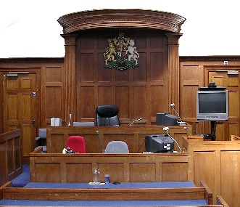 | Go to the Special Educational Needs Tribunal if:
 | - the Council will not look at your child’s needs, or if it will not make a statement.
 | - you are not happy with what is in the statement for your child.
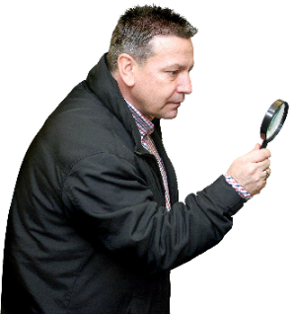 | What can the Ombudsman do?  We can do something if:
- there has been a long delay to look at your child’s special education needs.

- the Council has taken too long to give a statement of your child’s needs.
 | - there has been a long delay to do what the statement says for your child.
 | - the Council has not followed the rules.
What can’t the Ombudsman do?
We cannot do anything about:
 | - making the Council write a statement of special needs for your child if it does not think they need one.
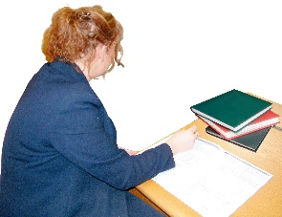 | - what the Council puts in the statement for your child.
 | Things to think about
If we agree with your complaint, we will tell the Council how it could make
things better.
 | This could mean giving you money to pay for help for your child.
 | The Ombudsman can tell the Council or housing association what we think it should do if we think it has done something wrong.
 | More information
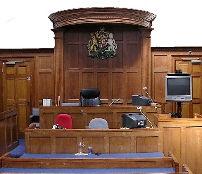 | Find out about the Special Educational Needs Tribunal for Wales at: www.sentw.gov.uk  or: 01597 829800
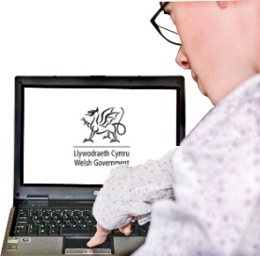 | The Welsh Government has more information in the education section of their website at: www.wales.gov.uk
You can also get information and
advice from:
Snap Cymru: www.snapcymru.org
and
The Advisory Centre for Education
www.ace-ed.org.uk
If you are still not sure if the
Ombudsman can help, contact us.
 | How to contact the Ombudsman
 | 0300 790 0203
ask@ombudsman.wales
www.ombudsman.wales
 | @OmbudsmanWales
The Public Services Ombudsman for Wales
1 Ffordd yr Hen Gae
Pencoed
CF35 5LJ
 | This easy read leaflet was prepared by Barod CIC using Photosymbols.

