This fact sheet is about:
School Exclusions
Exclusion means your child has broken the school rules.
They can no longer go to the school.
 | What do you do before you contact the Ombudsman?
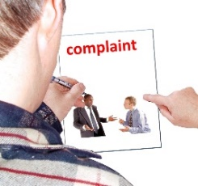 | Complain to the school governing body.
 | Appeal the decision to the Independent Appeals Panel.
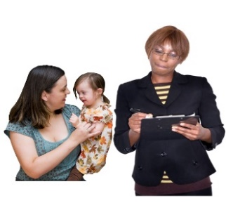 | Complain to the Council if it did not find another school for your child.

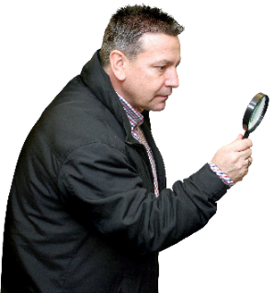 | What can the Ombudsman do?  We can do something if:
 | - the Appeals Panel did not do their job properly.
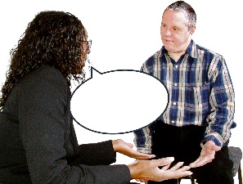 | - the Appeals Panel was not fair.  Think about if they let you bring people  to help you tell them what happened with your child.
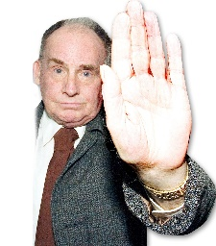 | - the Council did not give your child  a new school.
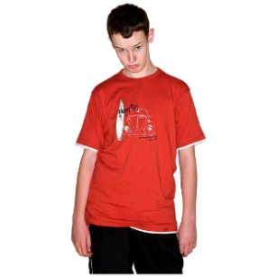 | - the new school is not right for your child.
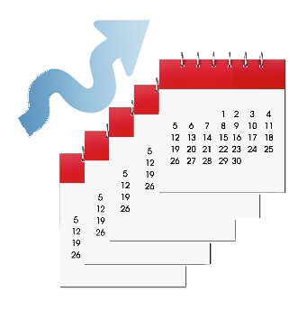 | - there was a long wait to get a new school for your child.
What can’t the Ombudsman do?
We cannot do anything about:
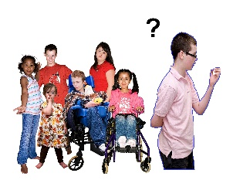 | - why the school is excluding your child.
 | - making the school change its mind.
 | - making the Council put your child back in that school or another school you have chosen.

 | Things to think about
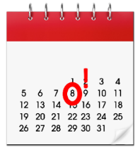 | If the school excludes your child for a set time you will not be able to appeal.
 | The Ombudsman can tell the Council or housing association what we think it should do if we think it has done something wrong.
 | More information
There is also an organisation called
Snap Cymru who can help.
Their website is www.snapcymru.org
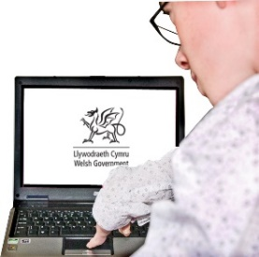 | Welsh Government have an online guide:  http://wales.gov.uk/docs/dcells/publications/120928exclusionguideen.pdf

If you are still not sure if the
Ombudsman can help, contact us.
 | How to contact the Ombudsman
 | 0300 790 0203
ask@ombudsman.wales
www.ombudsman.wales
 | @OmbudsmanWales
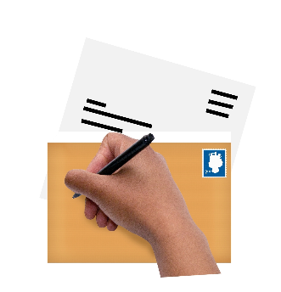 | The Public Services Ombudsman for Wales  1 Ffordd yr Hen Gae  Pencoed  CF35 5LJ
 | This easy read leaflet was prepared by Barod CIC using Photosymbols.

