This fact sheet is about:
School Admissions
and Appeals
What do you do before you contact the Ombudsman?
You can complain to the Council if your child can’t get into a school.
If your complaint is about the appeal you can come straight to the Ombudsman
What can the Ombudsman do?
We can do something if:
- the Council has not been fair and followed the rules.
- the Admissions Appeal Panel has not followed the rules.
What can’t the Ombudsman do?
We cannot do anything about:
- making the Council give your child a place at the school you want.
- complaints about private schools.

 | Things to think about
 | You need to think about whether the Council has been fair.
 | - Did it tell you how it chooses which children go to which school?
 | - The Council will try to let your child go to the school you want, but there may be too many children.
 | - Did the Council tell you what it would do if there are too many children for one school?
 | You need to think about if the Admissions Appeal Panel followed the rules:
 | - Did the Council tell you about the Admissions Appeal Panel?
 | - Did the Admissions Appeal Panel listen to you and the Council?
- The Appeal Panel can tell the school they must accept your child.
Even if the school is full.
 | More information
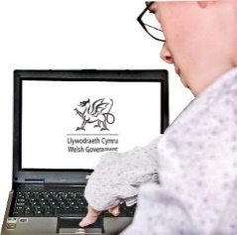 | Welsh Government have information at: gov.wales/school-admissions-code  gov.wales/school-admission-appeals-code
If you are still not sure if the
Ombudsman can help, contact us.
 | How to contact the Ombudsman
 | 0300 790 0203
ask@ombudsman.wales
www.ombudsman.wales
 | @OmbudsmanWales
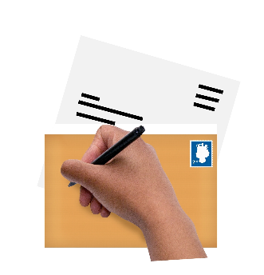 | The Public Services Ombudsman for Wales  1 Ffordd yr Hen Gae  Pencoed  CF35 5LJ
 | This easy read leaflet was prepared by Barod CIC using Photosymbols.

