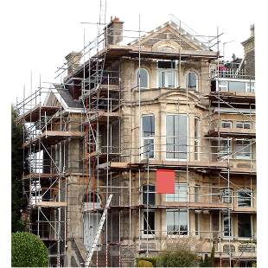 | This fact sheet is about: Planning Applications
 | A Planning Application is the way you must ask if you can build something.
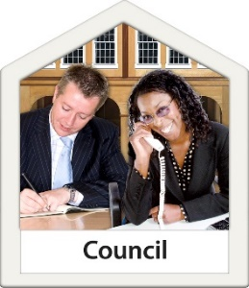 | The Council normally deals with  Planning Applications.
 | It decides what people can build.
 | The Council must follow the rules.
 | What do you do before you contact the Ombudsman?
 | Complain to your Council
What can the Ombudsman do?
We can look at whether:
 | The Council did not follow the rules.
 | The Council must:
 | - tell you that someone wants to build something that might affect you.
- tell everyone who should
have a say.
 | - ask you about plans they changed.
 | - say why it said yes to a plan.
- think about your worries about
the plan.

 | We can look at complaints about your own application like if the Council:
 | - gave you bad planning advice.
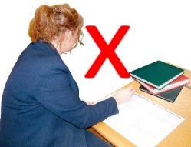 | - did not record their advice.
 | - did not follow the rules.

What can’t the Ombudsman do?
We cannot look at a complaint if:
- the Council followed the rules.
- there is a right to appeal.
- the Council have not decided yet.
- it is about a private argument.

 | More information
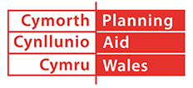 | Planning Aid Wales gives information on 029 2062 5000 or at: www.planningaidwales.org.uk
 | You can find more information found at: www.planningportal.gov.uk/wales/public
 | The Council’s website may also be helpful.
 | Things to think about
 | The Ombudsman can tell the Council what we think it should do if we think it has done something wrong.
If you are still not sure if the
Ombudsman can help, contact us.
 | How to contact the Ombudsman
 | 0300 790 0203
ask@ombudsman.wales
www.ombudsman.wales
 | @OmbudsmanWales
The Public Services Ombudsman for Wales
1 Ffordd yr Hen Gae
Pencoed
CF35 5LJ
 | This easy read leaflet was prepared by Barod CIC using Photosymbols.

