This fact sheet is about:
Housing
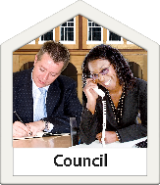 | It is about help if you need to complain about Council housing or Housing Associations.
 | They will have policies saying how they look at people’s needs.
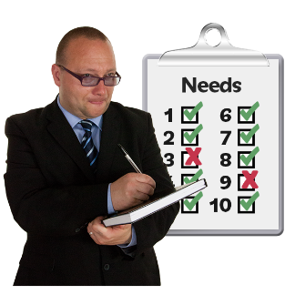 | You may need help with housing more than others if you are:
 | - homeless.

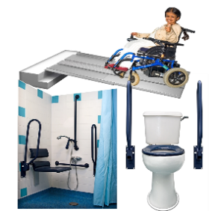 | - sick or disabled.
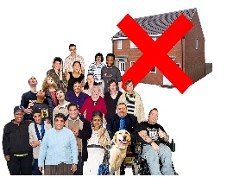 | - living with too many people.
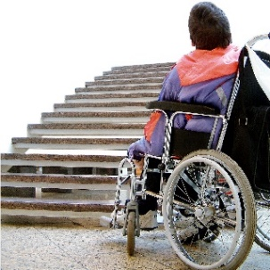 | - in a building not right for you.
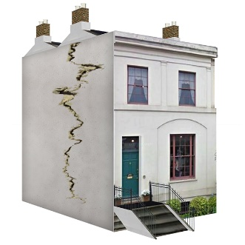 | - in a building that is not safe.
 | If you owe rent to another landlord the Council may not give you housing.

 | What do you do before you contact the Ombudsman?
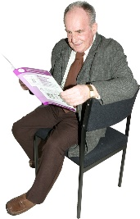 | Read our leaflet about being homeless.
Complain to your Council or
Housing Association

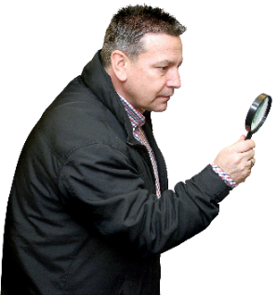 | What can the Ombudsman do?  We can look to see:
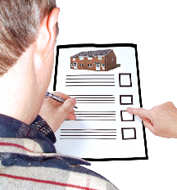 | - if your application was treated fairly.
 | - if the Council or Housing Association followed their rules.
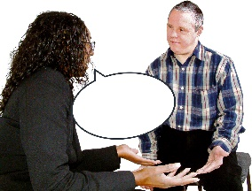 | - if you were told how your application was dealt with.
 | - if things moved too slowly when things got worse for you.
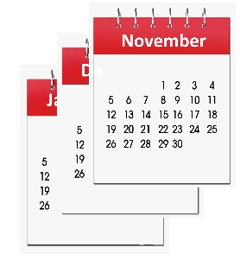 | - why your application may  be delayed.
What can’t the Ombudsman do?
We cannot:
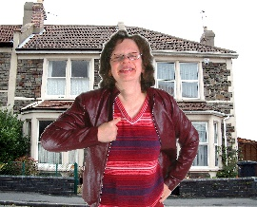 | make a Council or Housing Association give you a house.
 | change a decision when the Council has followed the rules.
 | Things to think about
There are not enough houses
for everyone.
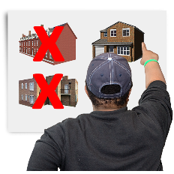 | You may not have much choice about the house or area you live.
 | If you say no to a house you may be taken off the list.
 | The Ombudsman can tell the Council or Housing Association what we think they should do if we think they have done something wrong.
 | More information
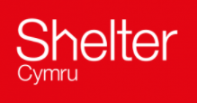 | Shelter Cymru gives free housing advice and support: 0845 075 5005  www.sheltercymru.org.uk
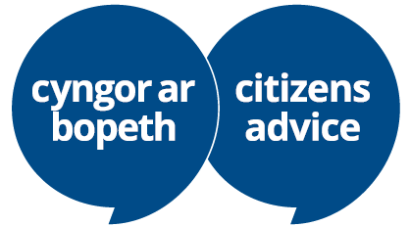 | Citizens Advice Cymru  gives free advice and support:  www.citizensadvice.org.uk/wales/
 | Your local Assembly Member may also be able to help.
If you are still not sure if the
Ombudsman can help, contact us.
 | How to contact the Ombudsman
 | 0300 790 0203
ask@ombudsman.wales
www.ombudsman.wales
 | @OmbudsmanWales
The Public Services Ombudsman for Wales
1 Ffordd yr Hen Gae
Pencoed
CF35 5LJ
 | This easy read leaflet was prepared by Barod CIC using Photosymbols.

