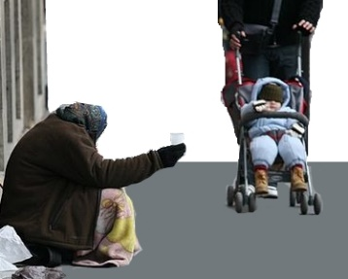 | This fact sheet is about: Homelessness
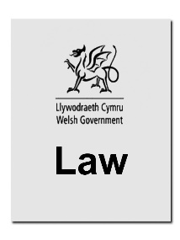 | The law says the Council must give some homeless people a place to live.
 | These are called People in Priority Need.
 | They must be offered somewhere to stay and be given help with their things.
 | The Council does not have to help if you made yourself homeless.
 | What do you do before you contact the Ombudsman?
 |  | Complain to your local Council
What can the Ombudsman do?
We can see if the Council did not:
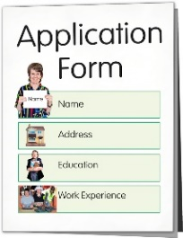 | - let you make a  homeless application.
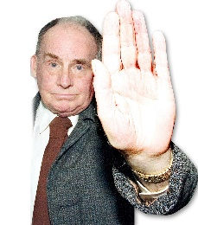 | - agree that you are homeless.
 | - offer you somewhere to stay if you are a Person in Priority Need.
 | - follow the rules.
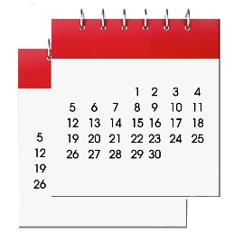 | - decide within 33 days.
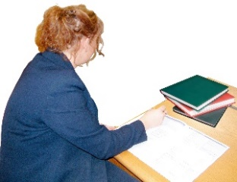 | - write to tell you what they decided and what you can do.
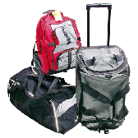 | - look after your things.
 | - deal with your case properly or fast enough.
What can’t the Ombudsman do?
We cannot:
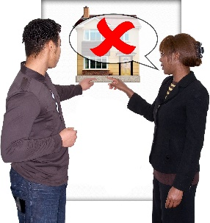 | - make the Council give you somewhere to live.
 | - do anything about a decision if the Council followed the rules.
 | Things to think about
 | The Council usually only thinks about giving homes to local people.
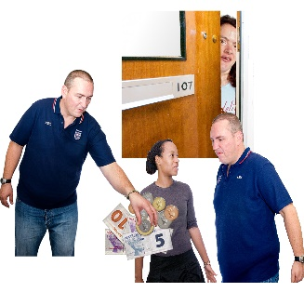 | Sometimes it helps other people if  they are in danger.
But it gives everyone advice
about their housing.
 | The Ombudsman can tell the Council what we think it should do if we think it did something wrong.

 | More information
 | Shelter Cymru gives housing advice and support. Phone 0845 075 5005 or go to: www.sheltercymru.org.uk
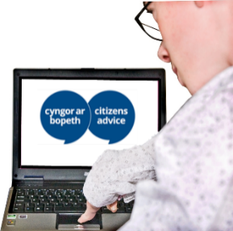 | Citizens Advice Cymru gives advice and support www.citizensadvice.org.uk
Welsh Women’s Aid helps people escaping from domestic violence
on 0808 8010 800 or www.welshwomensaid.org
 | Your Assembly Member can also offer help and advice.

If you are still not sure if the
Ombudsman can help, contact us.
How to contact the Ombudsman
0300 790 0203
ask@ombudsman.wales
www.ombudsman.wales
@OmbudsmanWales
The Public Services Ombudsman for Wales
1 Ffordd yr Hen Gae
Pencoed
CF35 5LJ
This easy read leaflet was prepared by Barod CIC using Photosymbols.

