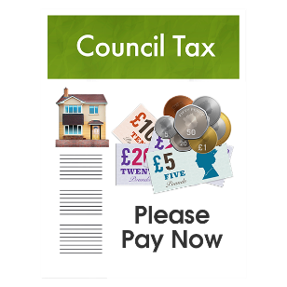 | This fact sheet is about:  Council Tax
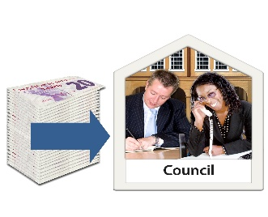 | Your Council decides what Council tax you must pay.
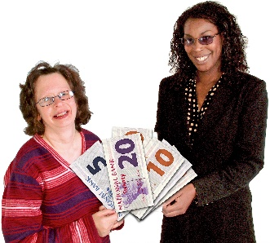 | The Council collects the Council tax  from you.
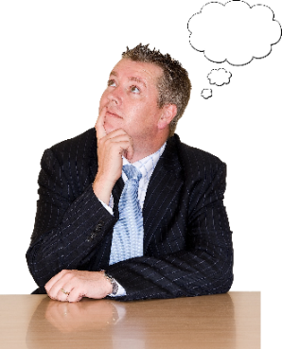 | What do you do before you contact the Ombudsman?
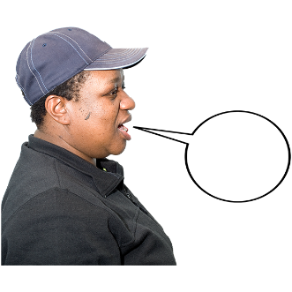 | You need to tell the Council if:
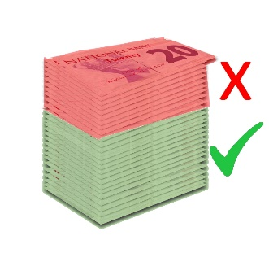 | - it has asked for the wrong money.
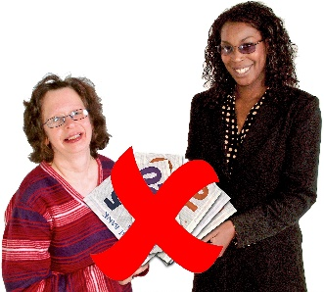 | - you are not the person who pays the Council tax.
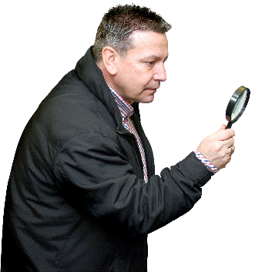 | What can the Ombudsman do?  We can do something if the Council:
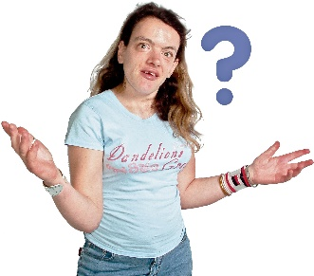 | - has not told you how much you  need to pay.
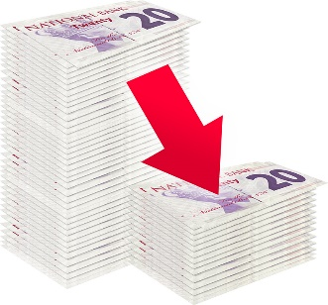 | - has not told you what to do if you think you are paying too much.
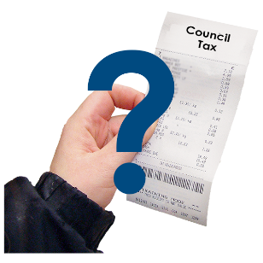 | - gets it wrong when you pay.

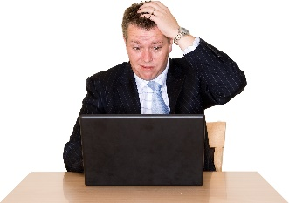 | What can’t the Ombudsman do?  We cannot:
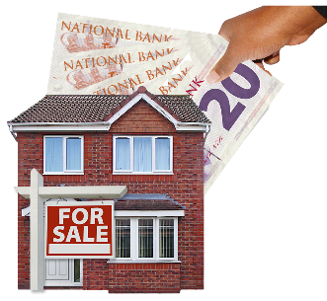 | - decide how much your house is worth.
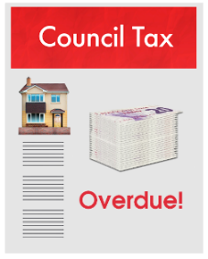 | - change your bill.
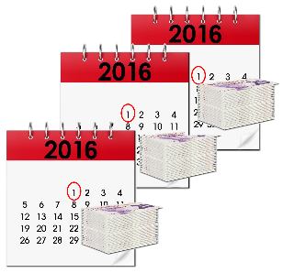 | - tell the Council how to make you pay your bill.
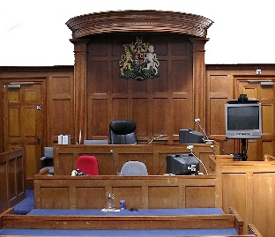 | - look at your complaint if you can go to appeal.
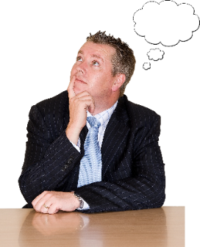 | Things to think about
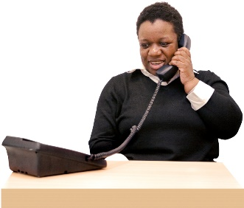 | If you think you are paying too much you must tell the Council.
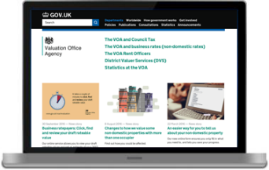 | You need to contact the valuation office.  www.voa.gov.uk
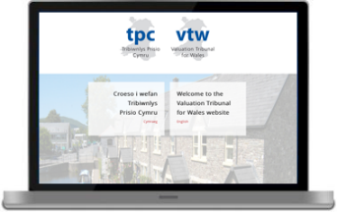 | If you and the Council do not agree you can ask the Valuation and Tribunal for Wales to decide.  www.valuation-tribunals-wales.org.uk
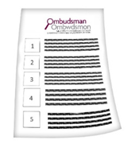 | The Ombudsman can tell the Council or housing association what we think it should do if we think it has done something wrong.
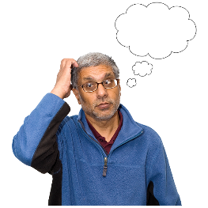 | If you are still not sure if the  Ombudsman can help, contact us.
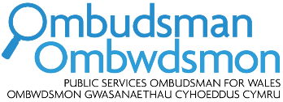 | How to contact the Ombudsman
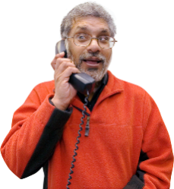 | 0300 790 0203
ask@ombudsman.wales
www.ombudsman.wales
 | @OmbudsmanWales
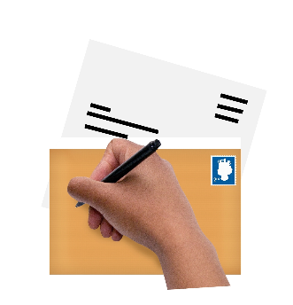 | The Public Services Ombudsman for Wales  1 Ffordd yr Hen Gae  Pencoed  CF35 5LJ
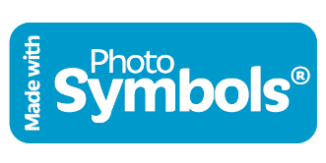 | This easy read leaflet was prepared by Barod CIC using Photosymbols.

