This fact sheet is about:
Commissioned and Private Healthcare
This is healthcare that is paid for by
the NHS.
 | What do you do before you contact the Ombudsman?
 | You must make a complaint to the provider of the service first.
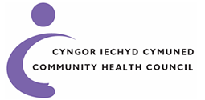 | Your Community Health Council (CHC) can help you make your complaint.
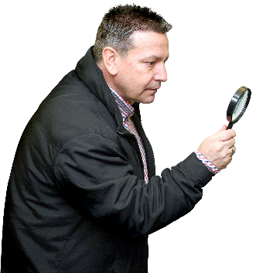 | What can the Ombudsman do?  We can do something if:
Your health care was paid for by NHS Wales.
Your care could have been in a:
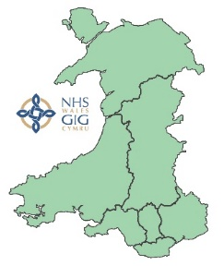 | - Hospital or clinic in Wales.
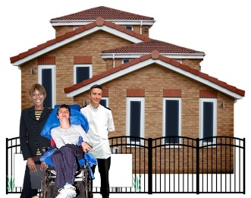 | - Private hospital.
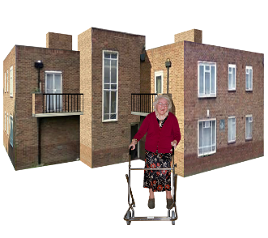 | - Private care home.
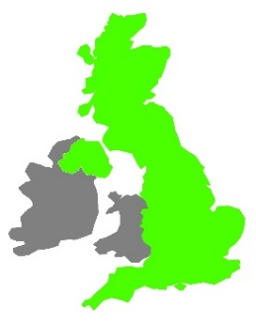 | - UK hospital (outside Wales).
What can’t the Ombudsman do?
We cannot do anything if:
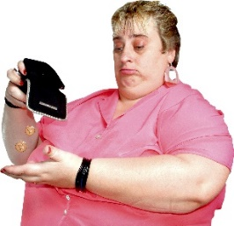 | - you paid for the healthcare.
- an insurance company paid for
the healthcare.
 | Things to think about
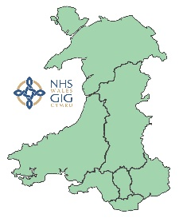 | You can find out who paid for your healthcare if you ask your Health Board.
 | The Ombudsman can tell the Care Provider what we think it should do if we think it has done something wrong.
 | More information
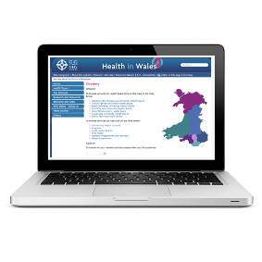 | You can find your local Health Board Here:  www.wales.nhs.uk/ourservices/directory
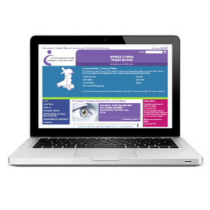 | Your local Community Health Council (CHC) can help you make  your complaint.  You can find your local CHC here: www.patienthelp.wales.nhs.uk  or on this helpline: 0845 6447814
If you are still not sure if the
Ombudsman can help, contact us.
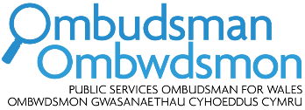 | How to contact the Ombudsman
 | 0300 790 0203
ask@ombudsman.wales
www.ombudsman.wales
 | @OmbudsmanWales
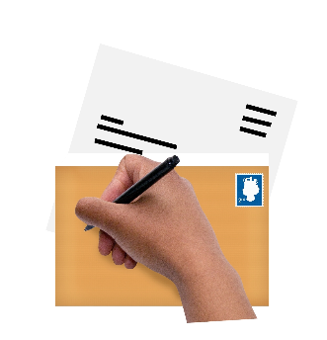 | The Public Services Ombudsman for Wales  1 Ffordd yr Hen Gae  Pencoed  CF35 5LJ
 | This easy read leaflet was prepared by Barod CIC using Photosymbols.

