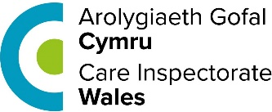 | This fact sheet is about:  Care Inspectorate Wales (CIW)
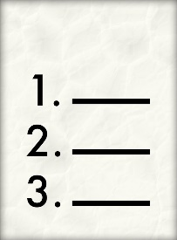 | CSSIW make sure social care services are run properly. It does this by:
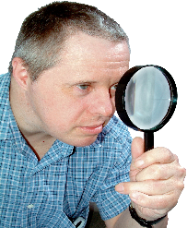 | - Inspections
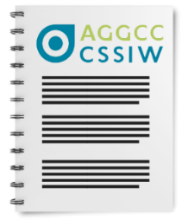 | - Regulations
 | - Reviewing
 | What do you do before you contact the Ombudsman?
 | Complain to CSSIW first.
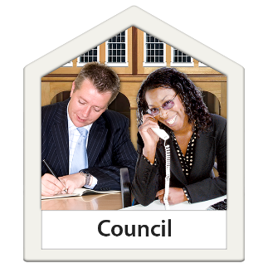 | Complaints about Social Services should be made to the Council.

What can the Ombudsman do?
We can do something if CSSIW:
 | - has not made other organisations follow the rules.
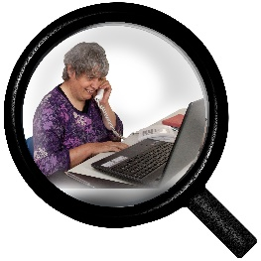 | - has not looked at the Council’s social services properly.
 | has not come back to you about your complaint.
 | - is not telling us about things properly.

What can’t the Ombudsman do?
We cannot do anything about:
- complaints about CSSIW staff.
- a properly made CSSIW decision.

Things to think about
The Council may get involved if they have paid for the service.
- We will look at complaints from people who pay for their own care.
The Ombudsman can tell CSSIW what we think it should do if we think it has done something wrong.

 | More information
 | More about CSSIW can be found here: cst@justice.gov.uk
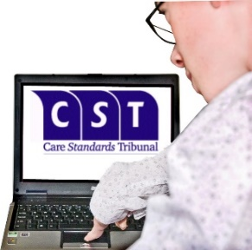 | If you think CSSIW made the wrong decision about standards being used you can go to the Care Standards Tribunal:  Phone 01325 289350  Email: cst@justice.gov.uk

If you are still not sure if the
Ombudsman can help, contact us.
How to contact the Ombudsman
0300 790 0203
ask@ombudsman.wales
www.ombudsman.wales
@OmbudsmanWales
The Public Services Ombudsman for Wales
1 Ffordd yr Hen Gae
Pencoed
CF35 5LJ
This easy read leaflet was prepared by Barod CIC using Photosymbols.

