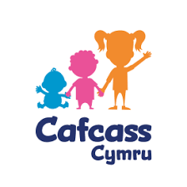 | This fact sheet is about:  CAFCASS Cymru
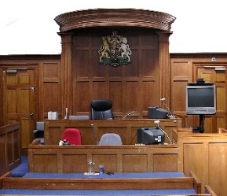 | CAFCASS Cymru works with families and children in court to:
 | - make sure children are safe and looked after.
 | - give advice to the courts.
 | - make sure children have someone to speak for them in court.
 | - provide information and advice to families and children.
 | What do you do before you contact the Ombudsman?
 | Complain to CAFCASS CYMRU.
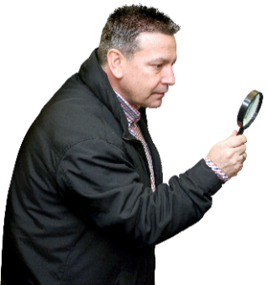 | What can the Ombudsman do?  We can do something if:
- you are not happy about the way CAFCASS CYMRU looked at
your complaint.
 | - Look at whether CAFCASS followed its own rules about a complaint.
What can’t the Ombudsman do?
We cannot do anything about:
- a complaint about people who
work for CAFCASS CYMRU.
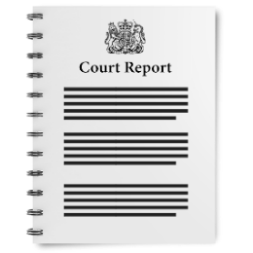 | - a report that has gone to the court.
 | Things to think about
If you are unhappy with a CAFCASS CYMRU report for the Court, you must
say this in Court.
 | The Ombudsman can tell CAFCASS Cymru what we think it should do if we think it has done something wrong.
 | More information
CAFCASS CYMRU
gov.wales/cafcass-cymru
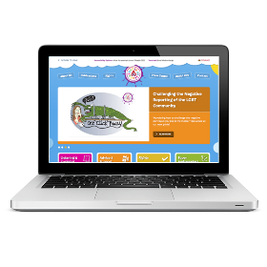 | The Children’s Commissioner for Wales may be able to act as an advocate for a child www.childcomwales.org.uk
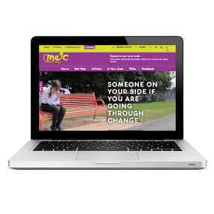 | Meic is a helpline for children and young people up to 25 www.meiccymru.org
If you are still not sure if the
Ombudsman can help, contact us.
 | How to contact the Ombudsman
 | 0300 790 0203
ask@ombudsman.wales
www.ombudsman.wales
 | @OmbudsmanWales
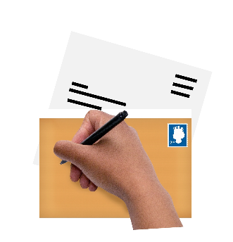 | The Public Services Ombudsman for Wales  1 Ffordd yr Hen Gae  Pencoed  CF35 5LJ
 | This easy read leaflet was prepared by Barod CIC using Photosymbols.

