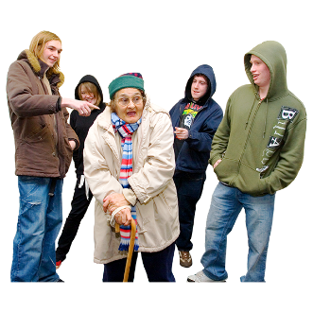 | This fact sheet is about:  Antisocial Behaviour
 | Antisocial behaviour includes:
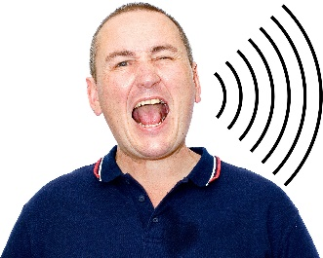 | - people making too much noise.
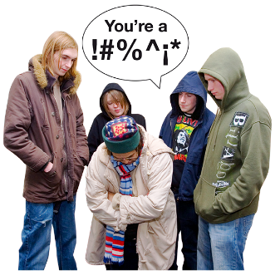 | - being rude.
 | - saying they will hurt someone.
 | - breaking or damaging someone’s things.
 | What do you do before you contact the Ombudsman?
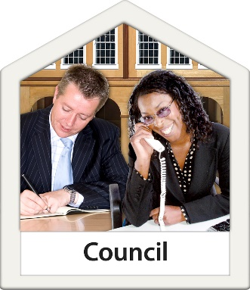 | Complain to your Council.
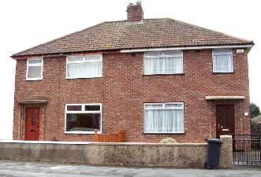 | If your home is owned by a Council or Housing Association, tell it.
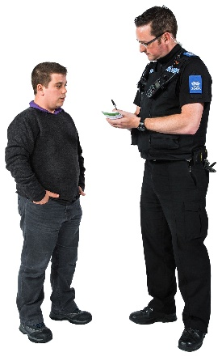 | Some behaviour may be a crime.  You should tell the police.
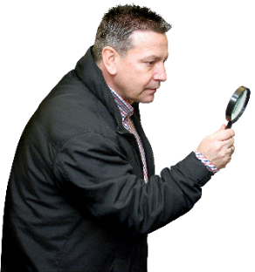 | What can the Ombudsman do?
 | We can do something if the Council or Housing Association:
 | - does not have rules to follow when it is told about antisocial behaviour.
 | - does not tell you the rules it will follow.
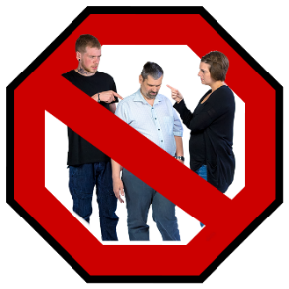 | - does not look at all the ways it can help stop the antisocial behaviour.
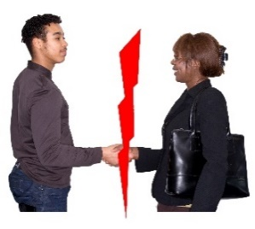 | - does not work with others including the police if needed.
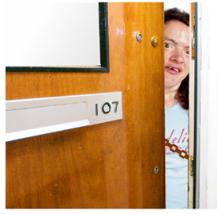 | - does not tell you how to keep safe.
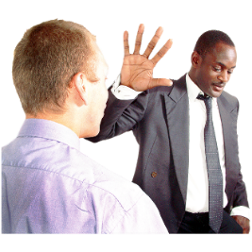 | - does not tell you what they are doing to stop the antisocial behaviour.
 | - takes too long to stop the antisocial behaviour.
What can’t the Ombudsman do?
We cannot do anything about:
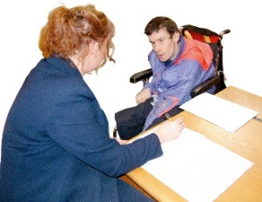 | - your complaint until you have told the Council or Housing Association.
 | - the Council or Housing Association if the antisocial behaviour stopped over 12 months ago.
 | Things to think about
 | You should keep a note of:
 | - when the antisocial behaviour started and what is happening.
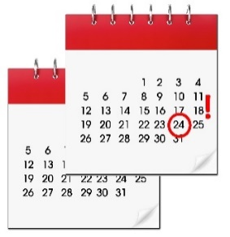 | - when you told the Council or Housing Association.
 | - anything that you told the Council or Housing Association.
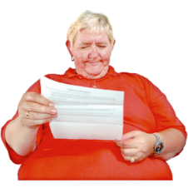 | - anything the Council or Housing Association told you.
 | The Ombudsman can tell the Council or Housing Association what we think it should do if we think it has done something wrong.
If you are still not sure if the
Ombudsman can help, contact us.
 | How to contact the Ombudsman
 | 0300 790 0203
ask@ombudsman.wales
www.ombudsman.wales
 | @OmbudsmanWales
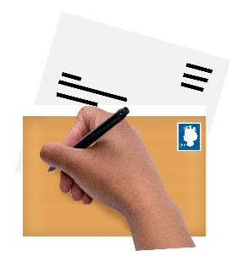 | The Public Services Ombudsman for Wales  1 Ffordd yr Hen Gae  Pencoed  CF35 5LJ
 | This easy read leaflet was prepared by Barod CIC using Photosymbols.

