 | This fact sheet is about: Public Rights of Way
 | Public Rights of Way means things like roads, footpaths and cycle ways.
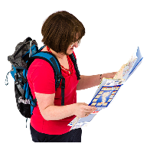 | The Council has a map of public rights of way in your area.
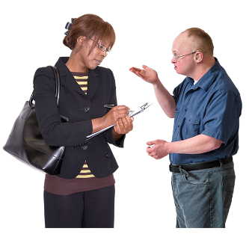 | If you think they have done something wrong you can tell them.
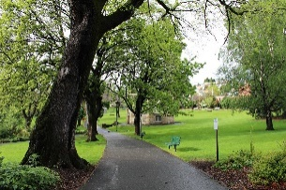 | Public Rights of Way are protected so you can use them.
 | What do you do before you contact the Ombudsman?
 | Complain to your Council.
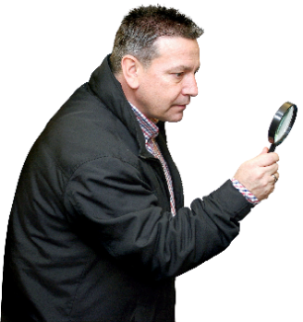 | What can the Ombudsman do?  We can do something if the Council
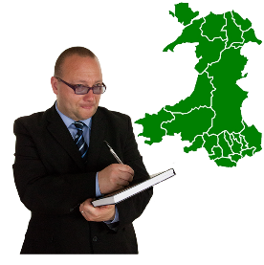 | - took too long to decide something about a public right of way.
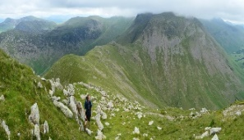 | - did not make sure the right of way was kept clear.
What can’t the Ombudsman do?
The Ombudsman cannot:
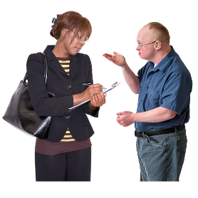 | - look at what the Council decided if you can appeal.
 | - look at a complaint if the Council followed the rules.
 | Things to think about
 | The Ombudsman can tell the Council what we think it should do if we think it did something wrong.
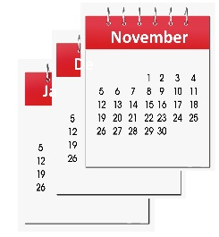 | Councils take a long time to decide about different rights of way.
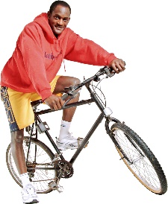 | This is because they need to look at how a right of way is used.
 | This means a lot of work for officers.
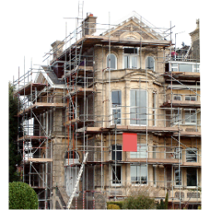 | Just because something is being built it does not mean there will be a change to a right of way.

 | More information:
 | The Ramblers Association website is at: www.ramblers.org.uk
 | Open Spaces Society website is at: www.oss.org.uk
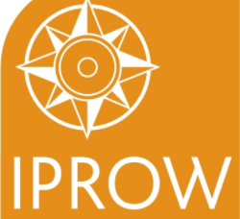 | Institute of Public Rights of Way and Access Management website is at: www.iprow.co.uk

If you are still not sure if the
Ombudsman can help, contact us.
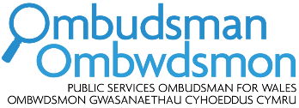 | How to contact the Ombudsman
 | 0300 790 0203
ask@ombudsman.wales
www.ombudsman.wales
 | @OmbudsmanWales
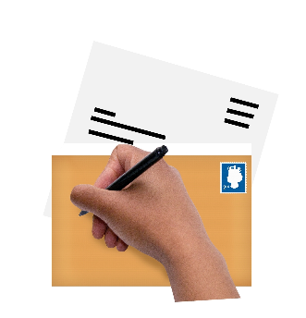 | The Public Services Ombudsman for Wales  1 Ffordd yr Hen Gae  Pencoed  CF35 5LJ
 | This easy read leaflet was prepared by Barod CIC using Photosymbols.

