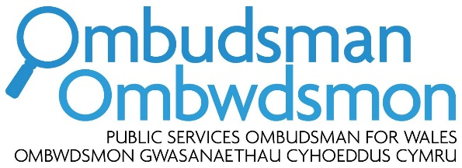

Response by the Public Services Ombudsman for Wales to the Welsh Government consultation ‘A More Equal Wales: Strengthening Social Partnership’

I am pleased to have the opportunity to respond to the Welsh Government consultation ‘A More Equal Wales: Strengthening Social Partnership’.
As Public Services Ombudsman for Wales (PSOW), I investigate complaints made by members of the public who believe they have suffered hardship or injustice through maladministration or service failure on the part of a body in my jurisdiction, which essentially includes all organisations that deliver public services devolved to Wales. These include:
- local government (both county and community councils)
- the National Health Service (including GPs and dentists)
- registered social landlords (housing associations)
- the Welsh Government, together with its sponsored bodies.
I am also able to consider complaints about privately arranged or funded social care and palliative care services and, in certain specific circumstances, aspects of privately funded healthcare.
Context
I respond to this consultation from my position as employer and leader of a public body in Wales, subject to other relevant duties (e.g. the equality duty). I am committed to the principle of the social partnerships and fair work duty proposed.
Question 1: Do you agree with proposals to strengthen social partnership arrangements by putting them on a statutory footing in legislation?
Question 2: Do you agree that strengthening social partnership arrangements will support Welsh Government ambitions to deliver a more equal Wales?
Question 4. Are these the right areas for legislation to deliver our proposals to strengthen social partnership arrangements and embed fair work principles across Wales?
I fully support the principle of social partnerships and fair work and believe that it is embedded in the work of my office - even in the absence of any separate, specific statutory duty requiring me to do so.
I am not opposed to the proposals to introduce such a duty for the relevant public bodies. However, I believe that any requirements under such a duty, especially so in relation to procurement, should be proportionate to the capacity, nature of operations and the likely impact on these bodies.
I also believe that such a duty should add value to both the existing and planned duties already supporting sound and fair employment and procurement practices (e.g. equality duty, well-being duty and socio-economic duty). These duties should be mutually reinforcing, while not creating an unnecessary administrative burden and complexity.
Question 3: Do you think that we should legislate to enforce decisions reached in social partnership and what form might that enforcement take?
I agree in principle that any duty introduced should be accompanied by sound arrangements for the monitoring of compliance. I do not offer an opinion on the merits of establishing a new Social Partnership Council for this purpose and I am looking forward to more details on the status and powers of the proposed body. However, as a point of principle, I’d observe that a clear route of redress should be available to the public bodies likely to be affected by the decisions of the proposed Council. This is especially so if such a body is to be endowed with any enforcement powers.
Closing remarks
I trust that you will find my comments useful. Should you wish to discuss any of my points further, please do not hesitate to contact Ania Rolewska, my Head of Policy (ania.rolewska@ombudsman.wales).

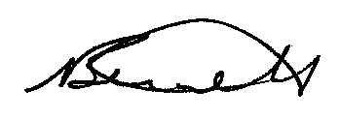

Nick Bennett

Public Services Ombudsman for Wales
November 2019
***************************************************************************

