This fact sheet is about:
Record Keeping
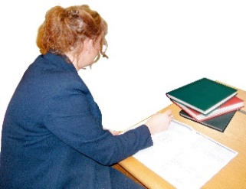 | Record keeping helps show that professionals made decisions in the right way and that services are good
 | What do you do before you contact the Ombudsman?
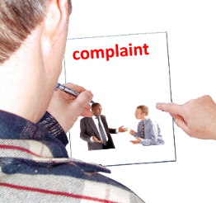 | Complain to the public organisation.
 | If a public organisation will not show you the records or you think something is wrong in the records, you should:
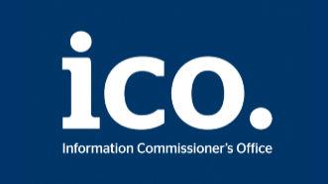 | contact the Information Commissioner’s Office on: 0303 123 1113 or www.ico.org.uk
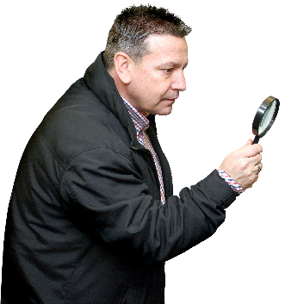 | What can the Ombudsman do?  We can do something if a public organisation:
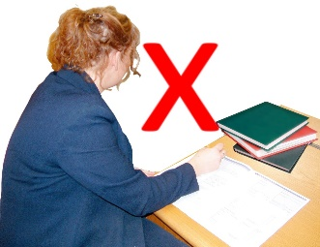 | - has not done a good job keeping records of what it does.
 | - has not kept a record of what it decided to do.
 | - has made something up in the records, instead of telling the truth.
 | - will not show you the records for a person who died.
What can’t the Ombudsman do?
We cannot do anything about:
 | - The public organisation not showing you records for someone who is still alive.
 | - The public organisation putting the record right about you, or what happened.

Things to think about
We may write a report.
This will show where the records
are wrong.
The Ombudsman can tell the Council or housing association what we think it should do if we think it has done something wrong.

If you are still not sure if the
Ombudsman can help, contact us.
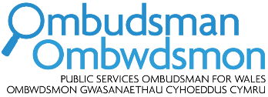 | How to contact the Ombudsman
 | 0300 790 0203
ask@ombudsman.wales
www.ombudsman.wales
 | @OmbudsmanWales
The Public Services Ombudsman for Wales
1 Ffordd yr Hen Gae
Pencoed
CF35 5LJ
 | This easy read leaflet was prepared by Barod CIC using Photosymbols.

