 | This fact sheet is about: Planning Enforcement
There are rules about what you can build.
The Council makes sure you follow them.
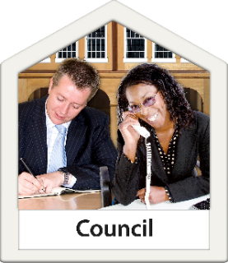 | The Council decides what can and cannot be built.
 | But if a plan is for building in a National Park, the National Park Authority decides.

 | What do you do before you contact the Ombudsman?
 | Complain to your Council
What can the Ombudsman do?
We can:
 | - see if the Council followed the rules.
 | - look at delays.
- ask the Council why it decided
what it did.
What can’t the Ombudsman do?
We cannot:
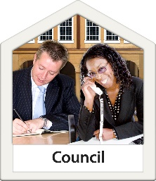 | - make a Council do something.
 | - look at a complaint if you were allowed to appeal.
 | Things to think about
 | Lots of things don’t need Planning Permission.
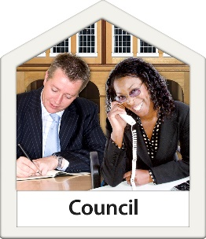 | Councils do not have to do anything if they think they do not need to.
 | Sometimes people build things without the Planning Permission they need.
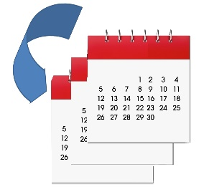 | Councils should let them ask for back dated Planning Permission.
 | Councils should have a policy you can see about Planning.
 | The Ombudsman can tell the Council what we think it should do if we think it has done something wrong.

 | More information
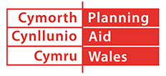 | Planning Aid Wales can help on:  029 2062 5000 or at www.planningaidwales.org.uk
You can find more information at:
www.planningportal.gov.uk/wales/public
 | Your Council website may also be helpful.

If you are still not sure if the
Ombudsman can help, contact us.
How to contact the Ombudsman
0300 790 0203
ask@ombudsman-wales.org.uk
www.ombudsman-wales.org.uk
@OmbudsmanWales
The Public Services Ombudsman for Wales
1 Ffordd yr Hen Gae
Pencoed
CF35 5LJ
This easy read leaflet was prepared by Barod CIC using Photosymbols.

