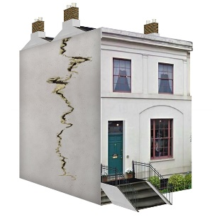 | This fact sheet is about: Housing Repairs
The Ombudsman can only look at complaints about Councils and
Housing Associations
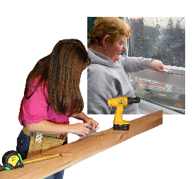 | The Councils and Housing Associations must do repairs on their houses.
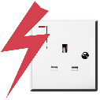 | The house can have gas and electrical things in it. Your landlord must make sure  they are safe.
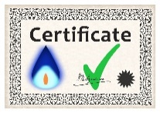 | You should be given a certificate to say they are safe.
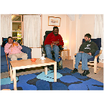 | If you are a tenant there are things you must take care of.
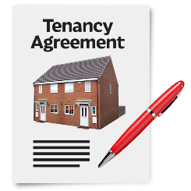 | Your tenancy agreement will say what you must do.
 | What do you do before you contact the Ombudsman?
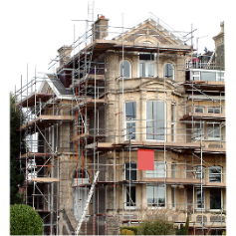 | Tell the Council or Housing Association if your house needs work. Give them time to do the repairs.
Complain to your Council or
Housing Association

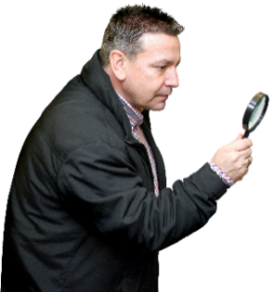 | What can the Ombudsman do?  We can look at complaints where the landlord has not:
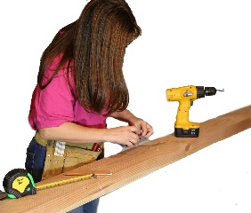 | - done repairs.
 | - done the repairs in good time.
- come to do repairs when they
said they would.
What can’t the Ombudsman do?
We cannot do anything about:
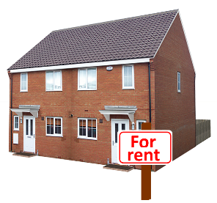 | - complaints about private landlords.
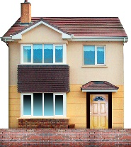 | - making the Council or Housing Association improve your home if it does not need it.
 | Things to think about
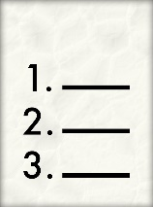 | Your tenancy agreement may say other things the Council or Housing  Association will do.
Your Council or Housing Association may give you a Tenants Handbook
for information.
 | The Ombudsman can tell the Council or Housing Association what we think it should do if we think it did something wrong.
 | More information
Shelter Cymru gives free housing advice and support: 0845 075 5005
www.sheltercymru.org.uk
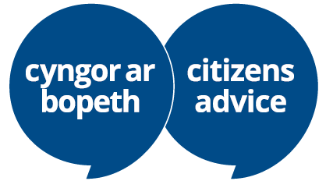 | Citizens Advice Cymru  gives free advice and support  www.citizensadvice.org.uk/wales/
Your local Assembly Member
may also be able to help.

If you are still not sure if the
Ombudsman can help, contact us.
How to contact the Ombudsman
0300 790 0203
ask@ombudsman.wales
www.ombudsman.wales
@OmbudsmanWales
The Public Services Ombudsman for Wales
1 Ffordd yr Hen Gae
Pencoed
CF35 5LJ
This easy read leaflet was prepared by Barod CIC using Photosymbols.

