This fact sheet is about:
Housing Benefit and
Council Tax Reduction
 | Councils must follow rules about Housing Benefit and Council Tax reduction.
 | What do you do before you contact the Ombudsman?
 | If you think the Council is wrong about a decision you should write to it.
 | If you think the Council did not follow the rules you can make a complaint.
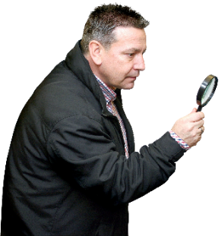 | What can the Ombudsman do?  The Ombudsman can check:
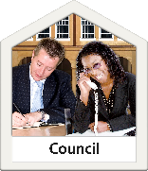 | - if the Council gave you proper advice about decisions and appeals.
- that the Council took money
from you fairly.
 | - if things went wrong when the Council was dealing with your case.

What can’t the Ombudsman do?
We cannot:
 | - help you make a benefit claim.
- make the Council give you
more benefit.
- make the Council cut the money
you owe them.
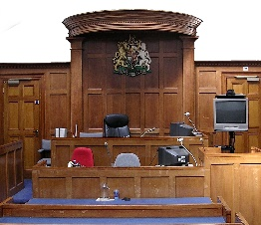 | - get involved if the Council takes you to court for fraud.
- help if you have already been
allowed to appeal.
 | Things to think about
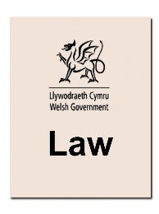 | The law says you can appeal Housing Benefit and Council Tax decisions.
 | Housing Benefit is being replaced by Universal Credit.
 | If you are unhappy about any benefits service, tell your local benefit office.
If you are still not happy you can complain to:
Parliamentary and Health Service Ombudsman on: 0345 015 4033
www.Ombudsman.org.uk
The Social Security and Child
Support Tribunal:
www.justice.gov.uk/tribunals/sscs
Valuation Tribunal for Wales:
www.valuation-tribunals-wales.org.uk/
 | More information
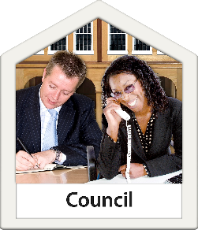 | Benefits Advice Services can help.  Your Council can tell you about these.
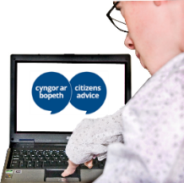 | Citizens Advice Bureau gives free advice  www.citizensadvice.org.uk
 | Cardiff Law Centre gives support to people in Cardiff: 029 2049 8117 www.lawcentres.org.uk.
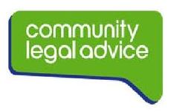 | There is a Community Legal Advice helpline on: 0845 345 4345 www.communitylegaladvice.org.uk.
 | and more at www.gov.uk
If you are still not sure if the
Ombudsman can help, contact us.
 | How to contact the Ombudsman
 | 0300 790 0203
ask@ombudsman.wales
www.ombudsman.wales
 | @OmbudsmanWales
The Public Services Ombudsman for Wales
1 Ffordd yr Hen Gae
Pencoed
CF35 5LJ
 | This easy read leaflet was prepared by Barod CIC using Photosymbols.

