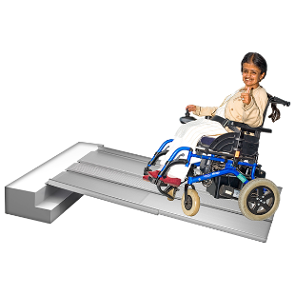 | This fact sheet is about:  The Disabled Facilities Grant
 | The Disabled Facilities Grant is:
 | - run by the Council.
 | - for people on a low income and without many savings.
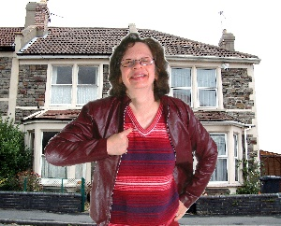 | - for people who live at home independently.
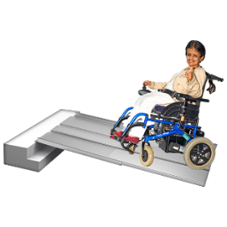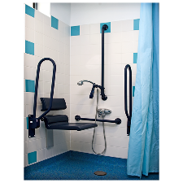 | The Grant can be for:  - ramps or stairlifts  - walk in showers  - new kitchens  - heating and lighting
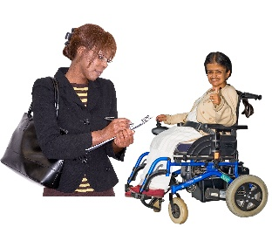 | An Occupational Therapist will visit you when you ask for a Grant.
 | They will help the Council decide how important the work is.
 | What do you do before you contact the Ombudsman?
 | If you live in a Council or Housing Association house, ask them about making your home accessible.
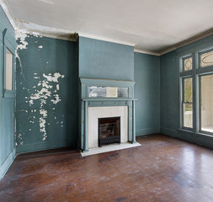 | If they cannot do this they can suggest you move to a more accessible home.
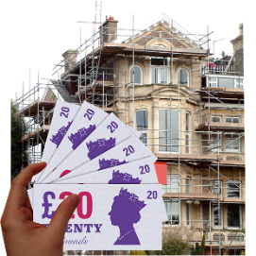 | The Council may also offer you a loan if the work costs more than the grant.
What can the Ombudsman do?
We can see if the Council:
 | - took too long to send an Occupational Therapist out to you.
 | - took too long to decide.
 | - looked at all the information before saying no.
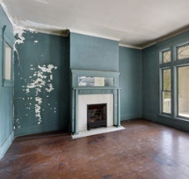 | - checked the builders work.
What can’t the Ombudsman do?
We cannot do anything about:
 | - the builder working on your house.
 | - making the Council give you money.
 | Things to think about
The Ombudsman can tell the Council or Housing Association what we think it should do if we think it has done
something wrong.

If you are still not sure if the
Ombudsman can help, contact us.
How to contact the Ombudsman
0300 790 0203
ask@ombudsman.wales
www.ombudsman.wales
@OmbudsmanWales
The Public Services Ombudsman for Wales
1 Ffordd yr Hen Gae
Pencoed
CF35 5LJ
This easy read leaflet was prepared by Barod CIC using Photosymbols.

