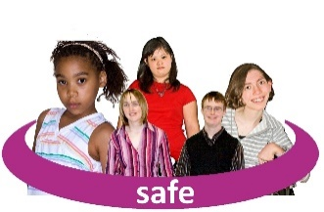 | This fact sheet is about:  Child Protection
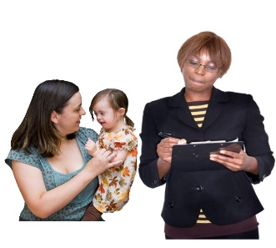 | Each Council has a duty to make sure all children are safe.  They must investigate if they think a child  is at risk.
 | What do you do before you contact the Ombudsman?
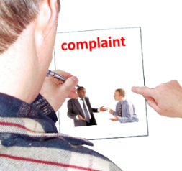 | Complain to the Council.
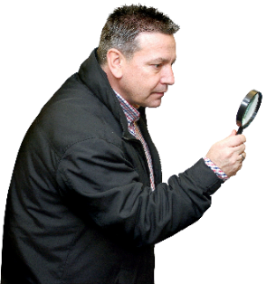 | What can the Ombudsman do?  We can do something if:
 | - the Council didn’t check properly if a child was at risk.
- the Council didn’t talk with the people or services that look after
the child.
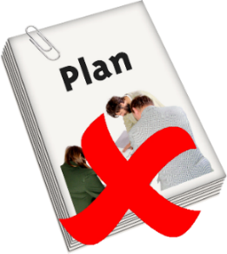 | - the Council didn’t make good plans to keep a child safe

What can’t the Ombudsman do?
We cannot do anything about:
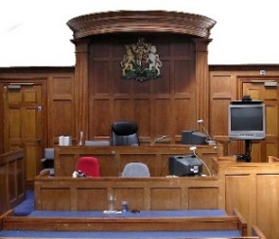 | - the Council deciding to go to court.
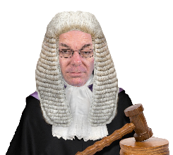 | - anything the court does.
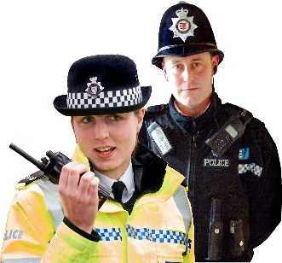 | - actions taken by the police.

 | Things to think about
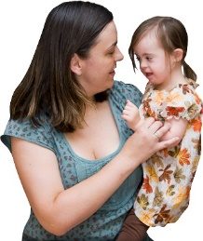 | Child protection is about what is best for the child.
 | The Ombudsman can tell the Council what we think it should do if we think it has done something wrong.
 | More information
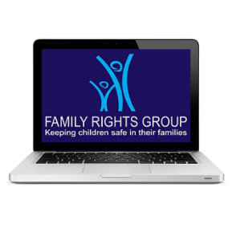 | You can get advice from the  Family Rights Group on: 0808 801 0366  Or at www.frg.org.uk
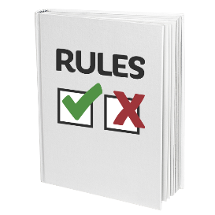 | You can read the rules about  Child Protection at:  www.awcpp.org.uk.
If you are still not sure if the
Ombudsman can help, contact us.
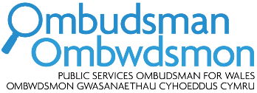 | How to contact the Ombudsman
 | 0300 790 0203
ask@ombudsman.wales
www.ombudsman.wales
 | @OmbudsmanWales
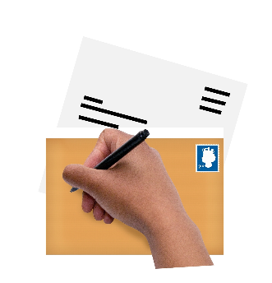 | The Public Services Ombudsman for Wales  1 Ffordd yr Hen Gae  Pencoed  CF35 5LJ
 | This easy read leaflet was prepared by Barod CIC using Photosymbols.

